**Course: C339 Data Fundamentals**

**Date: February 23, 2023**

**Title: Joins (INNER, LEFT, RIGHT, and FULL/UNION)**

Joining is the process of taking data from multiple tables and putting it into one generated view. So, an SQL JOIN clause in a SELECT statement combines columns from one or more tables in a relational database and returns a set of data.

FROM is also an essential part of the SELECT statement and this is where it’s specified which table we’re pulling data from. The joining part is if we want to bring data from multiple tables and we have three different types of joins:

1. **INNER join** – this is a default. If we don’t specify a type of join, it’s going to default as the inner join. This means if we are joining two tables on a common column, only return the data that matches on both tables.
2. **LEFT join** – This type of join returns all data on the left-handed table and only the data that matches the left-handed table in a right-handed table. LEFT OUTER JOIN is exactly the same as LEFT join.
3. **RIGHT join** – this type of join is the opposite of the above. It returns data from the right-handed table and only the data that matches the left-handed table.

**INNER JOIN**

Considering Tables 1 and 2 (below), INNER JOIN selects all rows from Tables 1 and 2 according to specified conditions. INNER JOIN will create the result-set by combining all rows from Tables 1 and 2 using customerNumber which is present in both tables.

Table 1 - Customers.

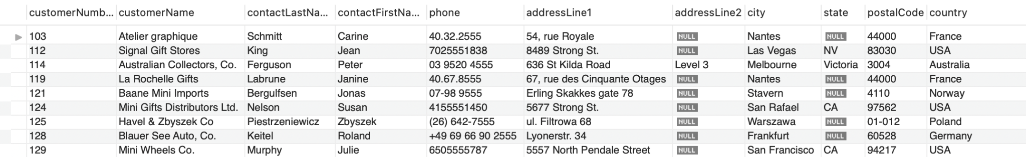

Table 2 - Orders.

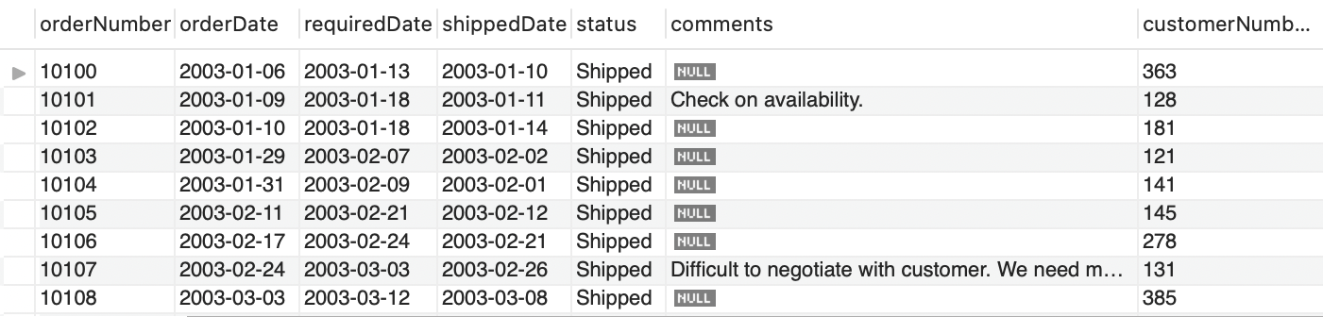

So to join Tables 1 and 2 using INNER JOIN, we can use the code below to obtain the joined output:



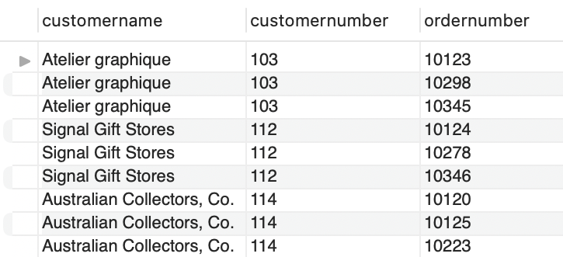

**LEFT join**

LEFT Join gives us everything from the left-handed table and only the records that match in the right-handed table. In our example, the query below will give us customers that made an order:



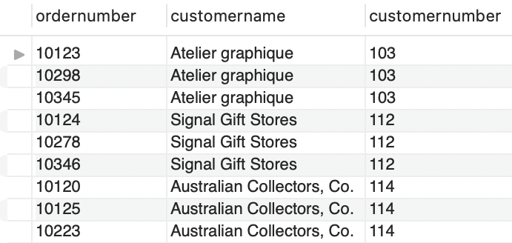

**RIGHT join**

RIGHT joins are the exact opposite of the LEFT join. They basically do the same thing. Left is right and right is left and the same effect can be rendered by just flipping the tables. RIGHT joins are in no way deprecated, they are just not all too common. For consistency’s sake, it is a common practice to use LEFT joins instead of RIGHT joins.

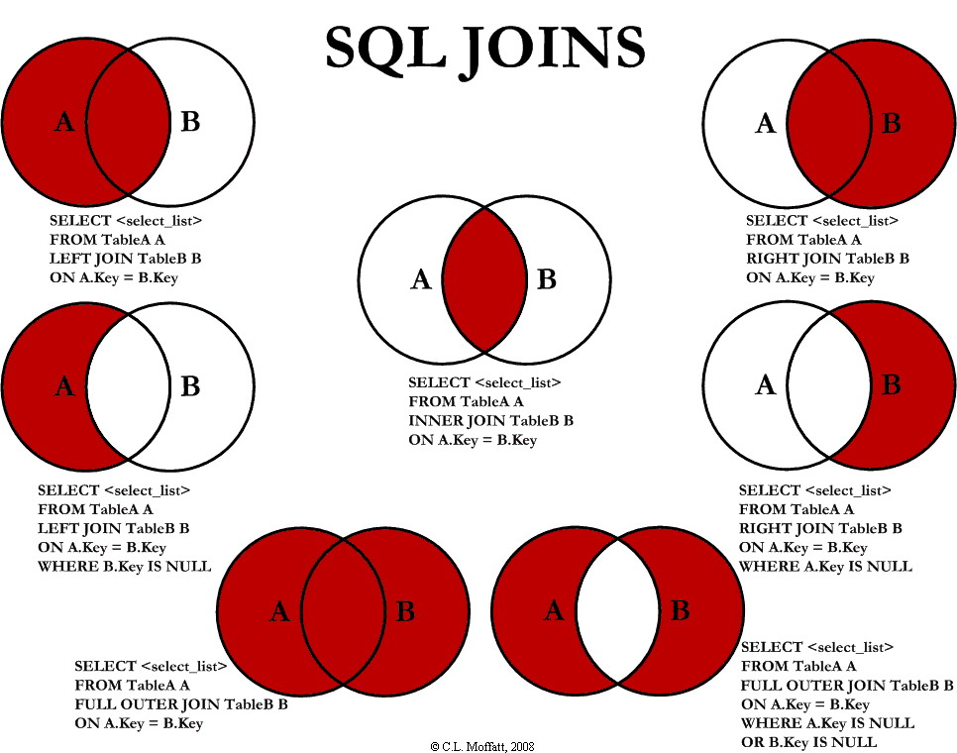

**UNION operator**

The UNION operator is used to combine the result-set of two or more SELECT statements. Some rules apply:

* Every SELECT statement within UNION must have the same number of columns.
* The columns must also have similar data types.
* The columns in every SELECT statement must also be in the same order.

UNION syntax:

SELECT *column_name(s)* FROM *table1*

UNION

SELECT *column_name(s)* FROM *table2*;

UNION ALL syntax

The UNION operator selects only distinct values by default. To allow duplicate values, use UNION ALL:

SELECT *column_name(s)* FROM *table1*

UNION ALL

SELECT *column_name(s)* FROM *table2*;